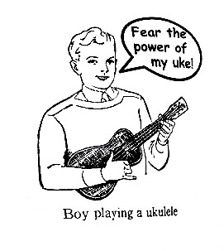Ukulele Songbook

Vol 2

Page

1. Wonderwall – Oasis

3. Aluminum – Barenaked Ladies

5. Wanted Dead or Alive – Bon Jovi

7. Space Oddity – David Bowie

9. The Drinking Song – Moxy Früvous

11. Dancing Queen – ABBA

12. Delia’s Gone – Johnny Cash

13. Kung-Fu Fighting – KC and The Sunshine Band

14. Can’t Buy Me Love – The Beatles

15. Fake Plastic Trees – Radiohead

17. I Can See Clearly Now – Johnny Nash

18. Have Yourself a Merry Little Christmas

19. I’m Yours – Jason Mraz

21. California Dreaming – The Mammas and the Papas

23. Life For Rent – Dido

25. We’ll Meet Again – Vera Lynn

26. Oh Susanna – Stephen Foster

27. Redshirt – Jonathan Coulton

29. Code Monkey – Jonathan Coulton

31. First of May – Jonathan Coulton

34. Skullcrusher Mountain – Jonathan Coulton

v 1.2

**Wonderwall – Oasis**

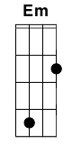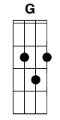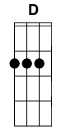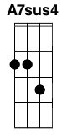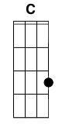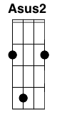

**Intro:**

**Em G D A7Sus4 (x3)**

**C D A7Sus4**

**Verse 1:**

**Em       G**

Today is gonna be the day that they’re

**D      A7Sus4**  
gonna throw it back to you  
**Em        G**

By now you shoulda some how

**D A7Sus4**

realized what you gotta do

**Em G**

I don’t believe that anybody

**D A7Sus4**

Feels the way I do

**C D A7Sus4**

about you now

**Verse 2:**

Backbeat the word is on the street that the **Em G**

fire in your heart is out **D A7Sus4**

I'm sure you've heard it all before but you **Em G**

never really had a doubt **D A7Sus4**

I don't believe that anybody **Em G**

feels the way I do **D A7Sus4**

About you now **C D A7Sus4**

**Bridge:**

**C**

And all the roads we

**D Em**

have to walk are winding

**C**

And all the lights that

**D Em**

lead us there are blinding

**C D**

There are many things that I

**G D Em**

Would like to say to you,

**D A7Sus4**

but I don't know how

**Chorus:**

**C Em G**

Cause maybe

**Em**

You're gonna be the one that

**C Em G**

saves me?

**Em C Em**

And after all

**G Em**

You're my wonder

**C Em G Em (silence) A2**

wall

**Verse 3:**

Today is gonna be the day but they'll **Em G**

never throw it back to you **D A7Sus4**

By now you should've somehow **Em G**

realized what you're not to do **D A7Sus4**

I don't believe that anybody **Em G**

feels the way I do **D A7Sus4**

About you now **C D A7Sus4**

**Bridge:**

And all the roads that **C**

lead you there are winding **D Em**

And all the lights that **C**

light the way are blinding **D Em**

There are many things that I **C D**

Would like to say to you, **G D Em**

but I don't know how **D A7Sus4**

**CHORUS: x3**

**Aluminum – Barenaked Ladies**

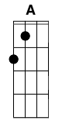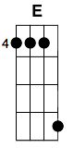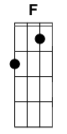

Intro Chords: **DFC, ACG, EGD** x4

**EGD DFC ACG EGD**

How, in every visible way you shine,

**DFC ACG EGD**

as if the stars in your wake align

**DFC ACG EGD**

Almost impossible to malign

**EGD DFC ACG EGD**

But just below where you shine you burn,

**DFC ACG EGD**

although I know it, I never learn

**DFC ACG EGD**

Just goes to show that I can't discern

CHORUS:

**DFC ACG EGD DFC ACG EGD**

Aluminum to me, aluminium to some.

**DFC ACG EGD**

You can shine like silver all you want

**DFC ACG EGD**

But you're just Aluminum

**EGD DFC ACG EGD**

Illuminating just what you want to show,

**DFC ACG EGD**

You'd never rust but I'd never know

**DFC ACG EGD**

You can't be trusted, I can't let go

**DFC ACG EGD DFC ACG EGD**

Aluminum to me, aluminium to some.

**DFC ACG EGD**

You can shine like silver all you want

**DFC ACG EGD**

But you're just Aluminum

**G?F ACG EGD DFC**

Every time you're here I forget,

**G?F ACG EGD**

When you leave, you leave only regret,

**DFC ACG EGD G?F ACG EGD**

Every time you're here, I forget **EGD**-very-thing

**EGD DFC ACG C EGD**

You're so lightweight, how can you survive?

**DFC ACG C EGD**

Recycling moments from others' lives

**DFC ACG C EGD**

You're not as precious as you contrive

**DFC ACG EGD DFC ACG EGD**

Aluminum to me, aluminium to some.

**DFC ACG EGD**

You can shine like silver all you want

**DFC ACG EGD**

But you're just Aluminum

**DFC ACG EGD**

But you're just Aluminum.

**DFC ACG EGD**

Yeah you're just aluminum.

Outro Chords: **DFC**, **ACG**, **EGD** x9, end on the 10th **DFC** Chord

**Wanted Dead or Alive – Bon Jovi**



**Intro:**

A|-----------|------------|-----------|-----------|-----------|-----------|---------|

E|----5---5--|----3---3---|-----------|-----------|------5----|------3----|---3-1---|

C|-2---------|--2---------|--2-5---5--|--2-4---4--|--2--------|--2--------|---------| x2

G|------10---|------9-----|------7----|------5----|----5---5--|----4---4--|---4-2---|

D U D

F D

A|--0---0---------------------|-----5--5-----------| A|-----0---0----|

E|--------------------1-------|--0-----------------| E|-----1---2----|

C|----------0-----2--------2--|--------------2-----| x3 C|--0--0---2----| x1

G|----------------------------|-----------2-----2--| G|-----2---2----|

**D C G**

It's all the same, only the names will change

**C G F D**

And ev'ry day, it seems we're wasting away

**D C G**

Another place , where the faces are so cold

**C G F D**

I'd drive all night , just to get back home

CHORUS:

**C G F D**

I'm a cowboy , on a steel horse I ride

**C G F D**

I'm wanted , dead or alive

**C G F D**

Wanted , dead or alive

**D C G**

Sometimes I sleep, sometimes it’s not for days

**C G F D**

and people I meet, always go their separate ways

**D C G**

Sometimes you tell the day, by the bottle that you drink

**C G F D**

And times when you’re alone, and all you do is think

CHORUS:

**C G F D**

I'm a cowboy, on a steel horse I ride

**C G F D**

I'm wanted , dead or alive

**C G F D**

Wanted , dead or alive

*repeat first part of intro x2*

**D C G**

And I walk these streets , a loaded six string on my back

**C G F D**

I play for keeps, 'cause I might not make it back

**D C G**

Been ev'ry where, still I'm standing tall

**C G F D**

I've seen a million faces , and I've rocked them all

CHORUS:

**C G F D**

'Cause I'm a cowboy , on a steel horse I ride

**C G F D**

I'm wanted (wanted) , dead or alive

**C G F D**

Well I'm a cowboy , I got the night on my side

**C G F D**

I'm Wanted (wanted) , dead or alive

**C G C G**

Dead or Alive , Dead or alive

**C G F D**

Dead or alive ,I still ride (still ride)

**C G C G**

Dead or alive , Dead or alive

**C G C G**

Dead or alive , dead or alive

**C G C G**

Dead or alive , Dead or alive...........

*Repeat first part of intro x2*

*instead of slide to 1 and 2 on second time strum D chord*

**Space Oddity – David Bowie**

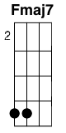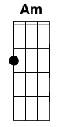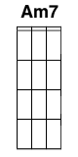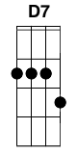

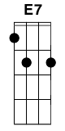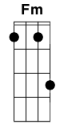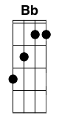

INTRO: **Fmaj7 Em Fmaj7 Em**

**C Em**

Ground Control to Major Tom

**C Em**

Ground Control to Major Tom

**Am Am7**

Take your protein pills

**D7**

and put your helmet on

**C Em**

Ground Control to Major Tom

**C Em**

Commencing countdown, engines on

**Am Am7**

Check ig-nition

**D7**

and may God's love be with you

[Take off is this chord: 2002

Slide this all the way down the fret board with a fast rhythm]

**C E**

This is Ground Control to Major Tom

**E7 F**

You've really made the grade

**Fm C F**

And the papers want to know whose shirts you wear

**Fm C F**

Now it's time to leave the capsule if you dare

**C E**

This is Major Tom to Ground Control

**E7 F**

I'm stepping through the door

**Fm C F**

And I'm floating in a most peculiar way

**Fm C**

And the stars look very different today

**Fmaj7**

For here

**Em**

Am I sitting in a tin can

**Fmaj7 Em**

Far above the world

**Bb Am**

Planet Earth is blue

**G F**

And there's nothing I can do

**C F G A A**

**C F G A A**

**C E**

Though I'm past one hundred thousand miles

**E7 F**

I'm feeling very still

**Fm C F**

And I think my spaceship knows which way to go

**Fm C F**

Tell my wife I love her very much she knows

**G E7**

Ground Control to Major Tom

**Am Am7**

Your circuit's dead, there's something wrong

**D7**

Can you hear me, Major Tom?

**C**

Can you hear me, Major Tom?

**G**

Can you hear me, Major Tom? Can you....

**Fmaj7**

For here

**Em**

Floating round my tin can

**Fmaj7 Em**

Far above the moon

**Bb Am**

Planet Earth is blue

**G F**

And there's nothing I can do

**C F G A A**

**C F G A A**

**The Drinking Song – Moxy Früvous**

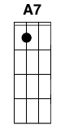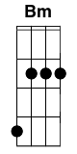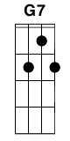

**G D7 G**

And the band played on

**G C D**

As the helicopters whirred

**C A7 G Em**

Drunk on the lawn in a nuclear dawn

**G D G**

My senses finally blurred

Verse 1:

**D7 G C G**

He was a rock, to the end a solid reminder

**Am D7**

Couldn't deny a friend

**D7 G C G**

We lived in the noise and the sweet amber poison

**Bm C**

Peekin' up the skirt of the end

**D7 G C G**

And we'd drink, two gnarly dudes and some records

**Am D7**

Much like plates of black food

**D7 G C G**

We filled up our faces, saw some far places

**Bm C D7**

Stood on the roof in the nude

**G D7 G**

And the band played on

**G C D**

As the helicopters whirred

**C A7 G Em**

Drunk on the lawn in a nuclear dawn

**G D G**

My senses finally blurred

Verse 2:

Between poles, he said "we're like cows in the grass" **D7 G C G**

Brushing off flies **Am D7**

Chaise lounging around standing up, falling down **D7 G C G**

'Till we no longer opened our eyes **Bm C**

And we'd drink, ever notice how drinking's like war **D7 G C G**

Cup 'o' troops o'er the gums **Am D7**

To the end of our health a campaign 'gaisnt myself **D7 G C G**

Armed with bourbons and scotches and rums **Bm C D7**

*-Chorus-*

Verse 3:

Think of bombs, we're poised on the edge of disaster **D7 G C G**

Whether it's right or it's wrong **Am D7**

We opened the window, played some Nintendo **D7 G C G**

Sang a few bars of some pretty old song: **Bm C**

**G C G D G**

Irene goodnight, Irene goodnight

**G G7 C**

Goodnight Irene goodnight Irene

**G D7 G D7**

I'll see you in my dreams

Oh to dream, those impotent bones of extinction **D7 G C G**

Flying graceful and free **Am D7**

None but the best cause the man cannot rest **D7 G C G**

'Till he's finally beaten his me **Bm C D7**

*-Chorus-*

Verse 4:

**D7 G C G**

'Till the end, he passed out on the sun deck that morning

Quietly saying goodbye **Am D7**

But I was so hammered I sputtered and stammered **D7 G C G**

Told him he couldn't just die **Bm C**

He was a rock, went straight for his own armageddon **D7 G C G**

Face froze in a grin **Am D7**

Ambulance flyin' in. I never drank again **D7 G C G**

Can't really call that a loss or a win **Bm C D7**

**G D7 G**

And the band played on

**G C D**

As the helicopters whirred

**C A7 G Em**

Drunk on the lawn in a nuclear dawn

**G D *C* G**

My senses finally blurred

**Dancing Queen – ABBA**

INTRO: **G C G** (2x **) D Em**

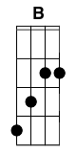

**D B**

You can dance, you can jive,

**Em Em7 A**

having the time of your life, ooh

**C D**

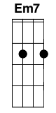See that girl, watch that scene,

**G C**

dig in the dancing queen

**G C**

Friday night and the lights are low

**G Em**

Looking out for the place to go

**D D**

Where they play the right music, getting in the swing

**Em D, Em, Em**

You come to look for a king

**G C**

Anybody could be that guy

**G Em**

Night is young and the music’s high

**D D**

With a bit of rock music, everything is fine

**Em D, Em, Em**

You’re in the mood for a dance

**Am D**

And when you get the chance...

CHORUS:

**D G**

You are the dancing queen,

**C G C**

young and sweet, only seventeen

**G**

Dancing queen,

**C G D Em**

feel the beat from the tambourine oh yeah

**D B**

You can dance, you can jive,

**Em Em7 A**

having the time of your life, Ooh

**C D**

See that girl, watch that scene,

**G**

dig in the dancing queen

**Delia’s Gone – Johnny Cash**

 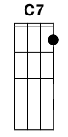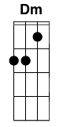

**AC AC DF AC A7C7**

Delia, oh Delia, Delia all my life

**DF  BmDm  EG**

If I hadn't-a shot poor Delia, I'd have had her for my wife

**AC DF AC EG AC**

Delia's gone, one more round, Delia's gone

**AC DF AC A7C7**

I went up to Memphis, and I met Delia there

**DF  BmDm  EG**

Found her in her parlor, and I tied her to her chair

**AC DF AC EG AC**

Delia's gone, one more round, Delia's gone

She was low-down and travelin', and she was cold and mean **AC DF AC A7C7**

Kind of evil make me want to grab my sub-machine **DF BmDm  EG**

Delia's gone, one more round, Delia's gone **AC DF AC EG AC**

First time I shot her, I shot her in the side **AC DF AC A7C7**

Hard to watch her suffer, but with the second shot she died **DF BmDm EG**

Delia's gone, one more round, Delia's gone **AC DF AC EG AC**

But jailer, oh jailer, jailer I can't sleep **AC DF AC A7C7**

'Cuz all around my bedside I hear the patter of Delia's feet **DF BmDm EG**

Delia's gone, one more round, Delia's gone **AC DF AC EG AC**

So if your woman's devilish, you can let her run **AC DF AC A7C7**

Or you can bring her down and do her like Delia got done **DF  BmDm  EG**

Delia's gone, one more round, Delia's gone **AC DF AC EG AC**

­

**AC DF AC EG AC EG AC**

Delia's gone, one more round, Delia's gone

**Kung-Fu Fighting – KC and The Sunshine Band**

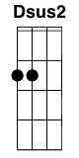

-Intro-

**D** (x4)

oh whoa.... | oh whoa....

chorus:

**D (Dsus2)**

Everybody was kung-fu fighting

**Em (E)**

those kicks were fast as lightning

**D (Dsus2)**

in fact it was a little bit frightening

**Em (E)**

but they fought with expert timing

verse:

**D Em**

They were funky china man, from funky china town

**D Em**

They were chopping men up, they were chopping men down

**D Em**

It's an ancient chinese art and every body knew their part

**D Em**

From a fainting to a slip and a kicking from the hip

-chorus-

verse:

There was funky Billy Chen and little Sammy Chong

He said, here comes the big boss! lets get it on

We took them all and made a stand, started swaying with the hands

Sudden motion made me skip, now were into a brand new trick

-chorus-

oh whoa...... (spoken -hah!) oh whoa...... (spoken -hah!)

oh whoa...... (spoken -huh!) oh whoa...... (spoken -hah!)

-chorus-

oh whoa...... (spoken -hah!) oh whoa...... (spoken -hah!)

oh whoa...... (spoken -huh!) oh whoa...... (spoken -hah!) (continue till fade out..)

**Can’t Buy Me Love – The Beatles**

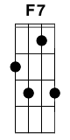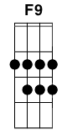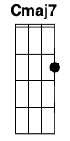

**Em Am Em Am**

Can't buy me lo-ove, lo-ove,

**Dm G7**

Can't buy me lo-ove.

**C7**

I'll buy you a diamond ring my friend, if it makes you feel alright.

**F7F9 C7**

I'll get you anything my friend, if it makes you feel alright.

**G7 F7F9 C7**

Cause I don't care too much for money, money can't buy me love.

**C7**

I'll give you all I've got to give, if you say you love me too.

**F7F9 C7**

I may not have a lot to give but what I got I'll give to you.

**G7 F7F9 C7**

‘Cause I don't care too much for money, money can't buy me love.

**Em Am C7**

Can't buy me love, everybody tells me so.

**Em Am Dm G7**

Can't buy me love, no, no, no, no.

**C7**

Say you don't need no diamond rings and I'll be satisfied.

**F7F9 C7**

Tell me that you want the kind of things that money just can't buy.

**G7 F7F9 C7**

I don't care too much for money, money can't buy me love.

[solo] **C7 F7F9 C7 G7 F7F9 C7**

**Em Am C7**

Can't buy me love, everybody tells me so.

**Em Am Dm G7**

Can't buy me love, no, no, no, no.

**C7**

Say you don't need no diamond rings and I'll be satisfied.

**F7F9  C7**

Tell me that you want the kind of things that money just can't buy.

**G7 F7F9 C7**

I don't care too much for money, money can't buy me love.

**Em Am Em Am**

Can't buy me love, love,

**Dm G7 Cmaj7**

Can't buy me love, oh.

**Fake Plastic Trees – Radiohead**

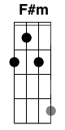

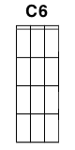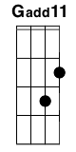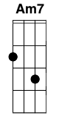

**AG F#mEm**

Her green plastic watering can

**DC**

For her fake chinese rubber plant

**AG DC C6 C**

In the fake plastic earth

**AG F#mEm**

That she bought from a rubber man

**DC**

In a town full of rubber plans

**AG DC**

To get rid of itself

**BmAm7**

It wears her out..

**AG Gadd11 G Gadd11**

It wears her out..

**BmAm7**

It wears her out..

**AG Gadd11 G Gadd11**

It wears her out

**AG F#mEm**

She lives with a broken man

**DC**

A cracked polystyrene man

**AG DC**

Who just crumbles and burns

**AG F#mEm**

He used to do surgery

**DC**

For girls in the eighties

**AG DC C6 C**

But gravity always wins

**BmAm7**

And it wears him out..

**AG Gadd11 G Gadd11**

It wears him out..

**BmAm7**

It wears him out..

**AG Gadd11 G Gadd11**

It weeeeeaaaars

**AG F#mEm**

She looks like the real thing

**DC C6 C**

She tastes like the real thing

**AG DC**

My fake plastic love

**AG F#mEm**

But I can't help the feeling

**DC**

I could blow through the ceiling

**AG DC C6 C**

If I just turn and run

**BmAm7**

And it wears me out

**AG Gadd11 G Gadd11**

It wears me out

**BmAm7**

It wears me out

**AG Gadd11 G Gadd11**

It wears me out

**BmAm7**

And if I could be who you wanted

**AG**

If I could be who you wanted

**BmAm7**

All the time..

**AG**

All the time..

**AG** (with more energy)

**F#mEm** (with more energy)

**DC** (with more energy, no change this time)

(end on) **AG**

**I Can See Clearly Now - Johnny Nash**

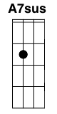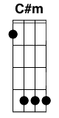

**D G D**

I can see clearly now the rain is gone

**D G A7 A7sus A7**

I can see all obstacles in my way

**D G D**

Gone all the dark clouds that had me blind

**C G D**

It's gonna be a bright, (bright) bright, (bright) sun shiny day

**C G D**

It's gonna be a bright, (bright) bright, (bright) sun shiny day

Coda: **Bb C D**

**D G D**

I think I can make it now the pain is gone,

**D G A7 A7sus A7**

All of the bad feelings have disappeared.

**D G D**

Here is the rainbow I have been praying for.

**C G D**

It's gonna be a bright, (bright) bright, (bright) sun shiny day

**F C**

Look all around, there's nothing but blue skies

**F A**

Look straight ahead, there's nothing but blue

**C#m G C#m G C Bm A7 A7sus A7**

skiiiiiiiiiiiiiiiiiiiiiiiies.

**D G D**

I can see clearly now the rain is gone

**D G A7 A7sus A7**

I can see all obstacles in my way

**D G D**

Gone all the dark clouds that had me blind

**C G D**

It's gonna be a bright, (bright) bright, (bright) sun shiny day (3x)

**Have Yourself a Merry Little Christmas – Ralph Blain & Hugh Martin**



**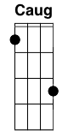****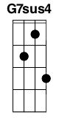****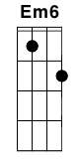**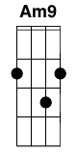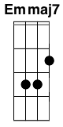

**C Am7 Dm G7**Have yourself a merry little Christmas

**C Am7 Dm G7**  
Let your heart be light

**C Am7 Dm G7 E7 A7 D7 G7**  
From now on our troubles will be out of sight

**C Am7 Dm G7**  
Have yourself a merry little Christmas

**C Am7 Dm G7**  
Make the Yule-tide gay

**C Caug F E7 Am C G7sus4 Caug**  
From now on our troubles will be miles away

**F Dm7-5 Em7 Em6**   
Here were are as in olden days

**Dm G7 Cmaj7 C6**   
happy golden days of yore

**Am Am9 Em Emmaj7**   
Faithful friends who are dear to us

**G D7 Dm G7**  
gather near to us once more

**C Am7 Dm G7**   
Through the years we all will be together

**C Am7 Dm G7**  
If the Fates allow

**C Caug F E7 Am C G7sus4 Caug**  
Hang a shining star upon the highest bough

**Fmaj7 Dm G7 C**  
And have yourself a merry little Christmas now

**I’m Yours – Jason Mraz**



**C**

Well, you done done me and you bet I felt it

**G**

I tried to be chill but you’re so hot that I melted

**Am F**

I fell right through the cracks, and I'm tryin’ to get back

**C**

before the cool done run out I'll be givin it my best test

**G**

and nothin's gonna stop me but divine intervention

**Am F**

I reckon it's again my turn to win some or learn some

CHORUS:

**C G Am**

I won't hesitate, no more, no more,

**F**

it cannot wait I'm yours

**C G**

Well open up your mind and see like me

**Am**

open up your plans and damn you're free

**F**

look into your heart and you'll find love love love

**C G**

listen to the music at the moment maybe sing with me

**Am**

All, a peaceful melody

**F D**

It's your god forsaken right to be loved loved loved loved Loved

CHORUS:

**C G**

So, I won't hesitate no more,

**Am F**

no more, it cannot wait I'm sure

**C G Am**

No need to complicate our time is short

**F**

this is our fate, I'm yours

-scat-

**C G Am G F D D7** x2

**C**

I've been spendin' way too long checkin' my tongue in the mirror

**G**

and bendin' over backwards just to try to see it clearer

**Am**

But my breath fogged up the glass

**F**

and so I drew a face and I laughed

**C**

I guess what I'm a sayin' is there ain't no better reason

**G**

to rid yourself of vanity and just go with the seasons

**Am F**

It's what we aim to do. Our name is our virtue

CHORUS:

**C G Am**

I won't hesitate no more, no more

**F**

it cannot wait, I’m sure

**C G**

(there's no need to complicate

**Am**

our time is short

**F**

it cannot wait, I’m yours [2x]

**C G Am**

no please don't complicate, our time is short

**F**

this is our fate, im yours.

**C G Am**

no please don't hesitate no more, no more

**F**

it cannot wait, the sky is yours!)

well open up your mind and see like me

open up your plans and damn you're free

look into your heart and you'll find love love love love

listen to the music of the moment come and dance with me

ah, la one big family

it's your god forsaken right to be loved, loved, loved, loved

open up your mind and see like me

open up your plans and damn you're free

look into your heart and you'll find love love love love

listen to the music of the moment come and dance with me

ah, la happy family

it's our god forsaken right to be loved loved loved loved

listen to the music of the moment come and dance with me

ah, la peaceful melodies

it's you god forsaken right to be loved loved loved loved...

**California Dreaming – The Mammas and the Papas**



Verse 1:

NC **Am G F**

All the leaves are brown (all the leaves are brown)

**G Am E**

And the sky is gray (and the sky is gray)

**F C E Am**

I've been for a walk (I've been for a walk)

**F Am E**

On a winter's day (on a winter's day)

**E Am G F**

I'd be safe and warm (I'd be safe and warm)

**G Am E**

If I was in L.A. (if I was in L.A.)

Chorus :

**E Am G F**

California dreamin’ (California dreamin')

**G Am E**

On such a winter's day

Verse 2:

**E Am**

Stopped in to a church

**G F**

I passed along the way

**G Am E**

Well I got down on my knees (got down on my knees)

**F Am E**

And I pretend to pray (I pretend to pray)

**E Am G F**

You know the preacher likes the cold (preacher likes thecold)

**G Am E**

He knows I'm gonna stay (knows I'm gonna stay)

Chorus :

**E Am G F**

California dreamin' (California dreamin')

**G Am E**

On such a winter's day

Instrumental break: Flute solo

**Am Am E Am G F G Am E**

Verse 3:

**E Am G F**

All the leaves are brown (all the leaves are brown)

**G Am E**

And the sky is gray (and the sky is gray)

**F C E Am**

I've been for a walk (I've been for a walk)

**F Am E**

On a winter's day (on a winter's day)

**E Am G F**

If I didn't tell her (if I didn't tell her)

**G Am E**

I could leave today (I could leave today)

Coda :

**E Am G F**

California dreamin' (California dreamin')

**G Am E G F**

On such a winter's day (California dreamin')

**G Am E G F**

On such a winter's day (California dreamin')

**G Am E Am**

On such a winter's day

**Life For Rent – Dido**



**Am F**

I haven't really ever found a place that I call home

**Am F**

I never stick around quite long enough to make it

**Am F**

I apologize that once again I'm not in love

**Am F**

But it's not as if I mind that your heart ain't exactly breaking

**Dm G7**

It's just a thought, only a thought

**C G F**

But if my life___ is for rent

**C G F G**

and I don't learn to buy

**C G F G**

Well I deserve nothing more than I get

**C G F**

'Cos nothing I have___ is truly mine

**Am F**

I've always thought that I would love to live by the sea

**Am F**

To travel the world alone and live more simply

**Am F**

I have no idea what's happened to that dream

**Am F**

'Cos there's really nothing left here to stop me

**Dm G7**

It's just a thought, only a thought

**C G F**

But if my life___ is for rent

**C G F G**

and I don't learn to buy

**C G F G**

Well I deserve nothing more than I get

**C G F**

'Cos nothing I have___ is truly mine

**C G F**

But if my life___ is for rent

**C G F G**

and I don't learn to buy

**C G F G**

Well I deserve nothing more than I get

**C G F**

'Cos nothing I have___ is truly mine

**C G Dm G**

While my heart is a shield and I won't let it down

**C G Dm G**

While I am so afraid to fail so I won't even try

**Dm G7**

Well how can I say I'm alive?

**C G F**

But if my life___ is for rent

**C G F G**

and I don't learn to buy

**C G F G**

Well I deserve nothing more than I get

**C G F**

'Cos nothing I have___ is truly mine

**C G F**

If my life___ is for rent

**C G F G**

and I don't learn to buy

**C G F G**

Well I deserve nothing more than I get

**C G F**

'Cos nothing I have___ is truly mine

**C G F**

Nothing I have___ is truly mine

**C G F**

Nothing I have___ is truly mine

**C G F**

'Cos nothing I have___ is truly mine

**We’ll Meet Again – Vera Lynn**

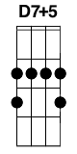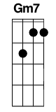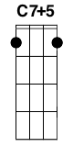

**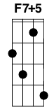****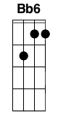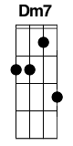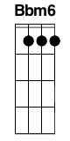**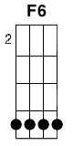

**F A7 D D7+5**

We'll meet again, don't know where, don't know when

**G7** **Gm7 C7 C7+5**  
But I know we'll meet again some sunny day

**F A7 D D7+5**  
Keep smiling through just like you always do

**G7** **Gm7 C7 F**  
'Till the blue skies drive the dark clouds far away

**F7 F7+5**  
So, will you please say hello to the folks that I know

**Bb Bb6**  
Tell them I won't be long

**G7 Dm7 G7**  
They'll be happy to know that as you saw me go

**Gm7 C7 C7+5**  
I was singing this song  
  
**F A7 D D7+5**

We'll meet again, don't know where, don't know when

**G7** **Gm7 C7 F Bbm6 F6**  
But I know we'll meet again some sunny day

**Oh Susanna – Stephen Foster**

**C G7**

I came from Alabama wid my banjo on my knee,

**C G7 C**

I’m g’wan to Louisiana my true love for to see,

**G7**

It rain’d all night the day I left, the weather it was dry,

**C G7 C G7**

The sun so hot I frose to death; Susanna, don't you cry.

Chorus:

**F C G7**

Oh! Susanna, Oh! don't you cry for me,

**C G7 C**

I’ve come from Alabama, wid my banjo on my knee.

I jumped aboard de telegraph,

And trabbelled down de ribber,

De Lectrie fluid magnified,

And killed five hundred Nigger

De bullgine bust, de horse run off,

I realy thought I’d die;

I shut my eyes to hold my breath,

Susanna, don't you cry.

-Chorus-

I had a dream de odder night

When ebery ting was still;

I thought I saw Susanna,

A coming down de hill.

The buckwheat cake war in her mouth,

The tear was in her eye,

Says I’m coming from de South,

Susanna, don't you cry.

-Chorus-

I scon will be in New Orleans,

And den I’ll look all round,

And when I find Susanna,

I’ fall upon the ground.

But if I do not find her,

Dis darkie ’I surely die,

And when I’m dead and buried,

Susanna, don't you cry.

-Chorus-

**Redshirt – Jonathan Coulton**

Intro: **ACG DFC ACG DFC ACG DFC ACG DFC**



**ACG DFC**

You hold up one hand

**F#mAmEm**

Everyone waits

**EGD**

Until we can move again

**ACG DFC**

The burden of command

**F#mAmEm**

Stands you up straight

**GBbF**

Something to prove again

**DFC**

Blood in your eyes

**BmDmAm**

Screams on the radio

**ACG DFC**

They say, "Get out of there!"

**BmDmAm**

We aren't finished yet

**EGD DFC**

You tell them to grow a pair

**ACG EGD**

They said this air would be breathable

**F#mAmEm DFC**

Get in, get out again, and no one gets hurt

**ACG EGD**

Something is pulling me up the hill

**DFC**

I look down in my red shirt

**BmDmAm ACG**

I look down in my red shirt

**DFC ACG DFC ACG DFC ACG DFC**

**ACG DFC**

This familiar place

**F#mAmEm**

Sun in my eyes

**EGD**

Right where I'm supposed to be

**ACG DFC**

I can read your face

**F#mAmEm**

I'm not surprised

**GBbF**

You move in close to me

**DFC**

Then you decide

**BmDmAm**

Now I'm remembering

**ACG DFC**

I've seen this one before

**BmDmAm**

I can't stop watching it

**EGD DFC**

So what am I running for?

**ACG EGD**

They said this air would be breathable

**F#mAmEm DFC**

Get in, get out again, and no one gets hurt

**ACG EGD**

You nod to me and point up the hill

**DFC**

I look down in my red shirt

**BmDmAm F#mAmEm EGD DFC**

I look down in my red shirt

**F#mAmEm EGD DFC**

At my red shirt

**ACG**   **DFC**

I don't hear the sound

**F#mAmEm**

Everything slows

**EGD**

All of it falls away

**ACG**   **DFC**

They don't turn around

**F#mAmEm**

Everyone knows

**GBbF**

It won't be them today

**DFC**

Instead it was me

**BmDmAm**

Go down dramatically

**ACG**   **DFC**

Stretching it out a bit

**BmDmAm**

Still no one notices

**EGD**  **DFC**

When they write me out of it

**ACG**  **EGD**

They said this air would be breathable

**F#mAmEm**  **DFC**

I see the naked sky and I taste the dirt

**ACG**  **EGD**

Dark at the edges and closing in

**DFC**

I look down in my red shirt

**BmDmAm ACG**

I look down in my red shirt

**DFC ACG DFC ACG DFC ACG**

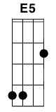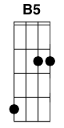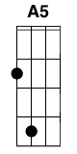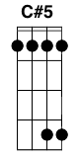**Code Monkey – Jonathan Coulton**

**E5**

Code Monkey get up get coffee

Code Monkey go to job

Code Monkey have boring meeting

With boring manager Rob

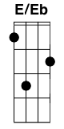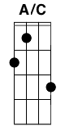**E5** **B5** **A5**

Rob say Code Monkey very diligent

**E5** **B5** **A5** **C#5** **B5**

But his output stink

**E5** **B5** **A5**

His code not "functional" or "elegant"

**E5** **B5** **A5**

What do Code Monkey think?

(break) **A5** **B5**

Code Monkey think maybe manager want to write god damned

**A/C C#5**

login page himself

**B5** **A5**

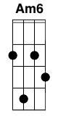****Code Monkey not say it out loud

**B5**

Code Monkey not crazy, just proud

**B5** **E5**

Code Monkey like Fritos

**E/Eb C#5 B5**

Code Monkey like Tab and Mountain Dew

**A5**

Code Monkey very simple man

**B5**

With big warm fuzzy secret heart:

**E5** **B5** **A5** **C#5** **B5**

Code Monkey like you

**E5** **B5** **A5**

Code Monkey hang around at front desk

**E5** **B5** **A5** **C#5** **B5**

Tell you sweater look nice

**E5** **B5** **A5**

Code Monkey offer buy you soda

**E5** **B5** **A5** **C#5** **B5**

Bring you cup, bring you ice

**E5** **B5** **A5**

You say no thank you for the soda cause

**E5** **B5** **A5** **C#5** **B5**

Soda make you fat

**E5** **B5** **A5**

Anyway you busy with the telephone

**E5** **B5** **A5**

No time for chat

**A5** **B5**

Code Monkey have long walk back to cubicle

**A/C C#5**

he sit down pretend to work

**B5** **A5**

Code Monkey not thinking so straight

**B5**

Code Monkey not feeling so great

**B5** **E5**

Code Monkey like Fritos

**E/Eb C#5 B5**

Code Monkey like Tab and Mountain Dew

**A5**

Code Monkey very simple man

**B5**

With big warm fuzzy secret heart:

**D A Am**

Code Monkey like you

**E D A Am Am6 Am7**

Code Monkey like you a lot

**E5** **B5** **A5**

Code Monkey have every reason

**E5** **B5** **A5** **C#5** **B5**

To get out this place

**E5** **B5** **A5**

Code Monkey just keep on working

**E5** **B5** **A5** **C#5** **B5**

See your soft pretty face

**E5** **B5** **A5**

Much rather wake up, eat a coffee cake

**E5** **B5** **A5** **C#5** **B5**

Take bath, take nap

**E5** **B5** **A5**

This job "fulfilling in creative way"

**E5** **B5** **A5**

Such a load of crap

**A5 B5**

Code Monkey think someday he have everything

**A/C C#5**

even pretty girl like you

**B5** **A5**

Code Monkey just waiting for now

**B5**

Code Monkey say someday, somehow

**B5** **E5**

Code Monkey like Fritos

**E/Eb C#5 B5**

Code Monkey like Tab and Mountain Dew

**A5**

Code Monkey very simple man

**B5**

With big warm fuzzy secret heart:

**E5** **B5** **A5** **C#5** **B5 E5** **B5** **A5** **C#5** **B5**

Code Monkey like you

**E5**

Code Monkey like you

**First of May – Jonathan Coulton**

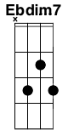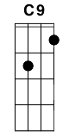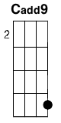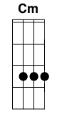

Intro: ||: **G** **C** | **G** **C** :||

*Verse 1:*

**G**

I woke up this morning

**C** **G** **C** **G**

I had a scone and a large house blend

**C** **G** **Am** **C** **D**

And then a little conversation with my squirrel and chipmunk friends

**G**

I said I'm sick and tired of winter

**C** **G** **C** **G**

And I wish that it was spring

**C** **G** **Am**

And then a little fellow named Robin Redbreast

**C** **D** **Ebdim7**

Began to sing

And he sang

*Pre Chorus 1:*

**Em** **Am**

Ooh ooh child, what'd you think the cold winter's gonna last forever

**Em** **Am** **D**

Ooh ooh child, now's the time for all the people to get together

**C9**

Outside

*Chorus:*

**G**

Cause it's the first of May, first of May

**C** **G**

Outdoor fucking starts today

**D**

So bring your favorite lady

**C** **G** **Am** **G** **C** **G7**

Or at least your favorite lay

**C** **G**

The water's not cold baby dip in your big toe

**D** **G**

Maybe I'll see you in flagrante delicto

**C** **G**

Grass below you, sky above

**Am** **Em**  **C** **Cadd9**

Celebrate spring with a crazy little thing called..

**G** **C** **G** **C**

fucking outside

*Verse 2:*

**G**

I thanked him for the information

**C** **G** **C** **G**

I cried a little when he flew away

**C** **G** **Am**

I watched an episode of The People's Court

**C** **D**

And I tried to plan my day

**G**

I called up my old lady

**C** **G** **C** **G**

She wasn't home so I called my girl

**C** **G** **Am**

I asked her if she'd like to join me as I

**C** **D** **Ebdim7**

Entertain the world

And I said

*Pre Chorus 2:*

**Em** **Am**

Ooh ooh child, I'll bring a blanket and I promise

I will brush the ants off

**Em** **Am**

Ooh ooh child, you're gonna like it when we're taking

**D**

each other's pants off

**C9**

Outside

*Chorus:*

**G**

Cause it's the first of May, first of May

**C** **G**

Outdoor fucking starts today

**D**

So bring your favorite lady

**C** **G** **Am** **G** **C** **G7**

Or at least your favorite lay

**C** **G**

The water's not cold baby dip in your big toe

**D** **G**

Maybe I'll see you in flagrante delicto

**C** **G**

Grass below you, sky above

**Am** **Em**  **C** **Cadd9**

Celebrate spring with a crazy little thing called..

**G** **C** **G** **C**

fucking outside

*Verse 3:*

**G**

So we went to the park together

**C** **G** **C** **G**

We were walking in the midday sun

**C** **G** **Am**

We met all kinds of people and

**C** **D**

We fucked everyone

**G**

We fucked a lady who sells ice cream

**C** **G** **C** **G**

We fucked a man with a tan Shar Pei

**C** **G** **Am** **C**

Everyone who needed fucking well they

**D** **Ebdim7**

They got fucked today

So come on

*Pre Chorus 3:*

**Em** **Am**

Ooh ooh child, open your mind and your heart, feel the spirit moving through you

**Em** **Am** **D**

Ooh ooh child, you'll feel the warmth of the love when I stick it to you

**C9**

Outside

*Final Chorus:*

**G**

Cause it's the first of May, first of May

**C** **G**

Outdoor fucking starts today

**D**

So bring your favorite lady

**C** **G** **Am** **G** **C** **G7**

Or at least your favorite lay

**C** **G**

The water's not cold baby dip in your big toe

**D** **G**

Maybe I'll see you in flagrante delicto

**C** **G**

Grass below you, sky above

**Am** **Em** **C** **Cadd9**

Celebrate spring with a crazy little thing called..

**G**

fucking outside

**C** **G**

fucking outside

**C** **G** **C** **Cm** **G**

fucking outsiiiiiiide



**Skullcrusher Mountain – Jonathan Coulton**

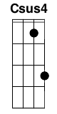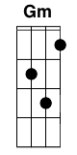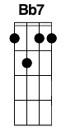

**Intro**: |**C** |**Csus4** |**C** |**Csus4** |

**C** **Csus4** **C** **Csus4**

Welcome to my secret lair on Skullcrusher Mountain

**C** **Csus4**

I hope that you've enjoyed your stay so far

**C7**

I see you met my assistant Scarface

**F** **C**

His appearance is quite disturbing

**F** **G7**

but I assure you he's harmless enough

**F** **C**

He's a sweetheart, calls me Master

**F** **G7** **F** **G7**

And he has a way of finding pretty things

**F** **G7**

and bringing them to me

**C**

I'm so into you

**Gm**

But I'm way too smart for you

**F**

Even my henchmen think I'm crazy

**Fm**

I'm not surprised that you agree

**C**

If you could find some way to be

**Gm**

A little bit less afraid of me

**F**

You'd see the voices that control me

**Fm**

from inside my head

**Bb7** **C** **Csus4**

Say I shouldn't kill you....yet

**C** **Csus4** **C** **Csus4**

I made this half-pony half-monkey monster to please you

**C** **Csus4**

But I get the feeling that you don't like it

**C7**

What's with all the screaming?

**F** **C**

You like monkeys, you like ponies

**F** **G7**

Maybe you don't like monsters so much

**F** **C**

Maybe I used too many monkeys

**F** **G7** **F** **G7**

Isn't it enough to know that I ruined a pony

**F** **G7**

making a gift for you?

**C**

I'm so into you

**Gm**

But I'm way too smart for you

**F**

Even my henchmen think I'm crazy

**Fm**

I'm not surprised that you agree

**C**

If you could find some way to be

**Gm**

A little bit less afraid of me

**F**

You'd see the voices that control me

**Fm**

from inside my head

**Bb7** **C** **Csus4** **C** **C7**

Say I shouldn't kill you....yet

**F Em**

Picture the two of us alone inside my golden submarine

**F** **G7**

While up above the waves my doomsday squad

**C** **C7**

ignites the atmosphere

**F**

And all the fools who lead their foolish lives

**Em A7**

may find it quite explosive

**Dm F G7**

Well it won't mean half as much to me if I don't have you here

**C** **Csus4** **C** **Csus4**

You know it isn't easy living here on Skullcrusher Mountain

**C** **Csus4**

So maybe you could cut me just a little slack

**C7**

Would it kill you to be civil?

**F** **C**

I've been patient, I've been gracious

**F** **G7**

And this mountain is covered with wolves

**F** **C**

Hear them howling, my hungry children

**F** **G7** **F** **G7**

Maybe you should stay and have another drink

**F** **G7**

and think about me and you

**C**

I'm so into you

**Gm**

But I'm way too smart for you

**F**

Even my henchmen think I'm crazy

**Fm**

I'm not surprised that you agree

**C**

If you could find some way to be

**Gm**

**F** little bit less afraid of me

**F**

You'd see the voices that control me

**Fm**

from inside my head

**Bb7** **C**

Say I shouldn't kill you yet

**Bb7** **C**

I shouldn't kill you yet

**Bb7** **C** **Csus4** **C**

I shouldn't kill you yet



Chords – GCEA (Standard) Tuning

Maj/Minor

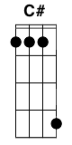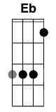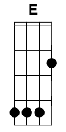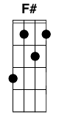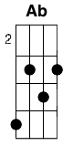

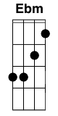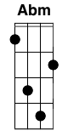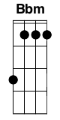

7

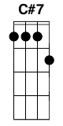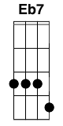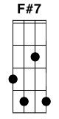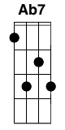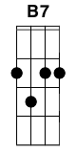

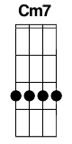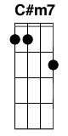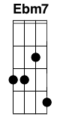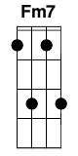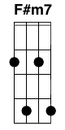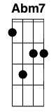****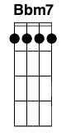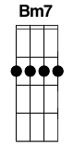

Maj

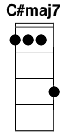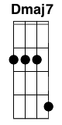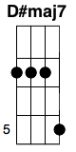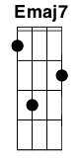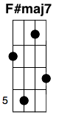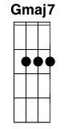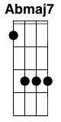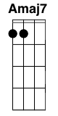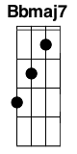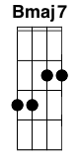

Sus

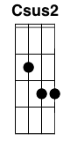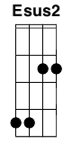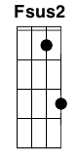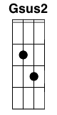

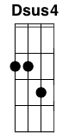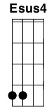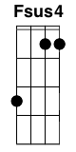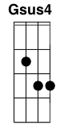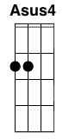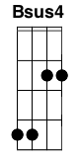

5

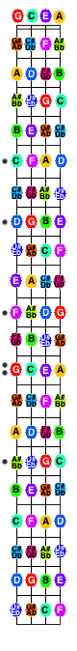    

6

  

 

9

 

Misc

********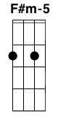



Variations

